Council for Disabled Children

SEND Outcome Dashboard

How to guide

Contents

**1.** **Overview** 2

**2.** **How to update the data templates with your data** 2

2.1 Downloading the templates 2

2.2 SEND Outcome Indicator dataset template 3

2.2.1 Understanding Placeholder rows 3

2.2.2 Adding your data to the datasets 4

2.2.3 Adding indicator totals 5

2.2.4 Adding demographic breakdowns 6

2.2.5 Being aware of pre-set conditions 7

**3** **How to link to and refresh the dataset in Power BI and Excel** 9

3.1 Uploading data into the Excel Dashboard 9

3.1.1 Copy data from the dataset template 9

3.1.2 Paste data into the Excel dashboard 9

3.1.3 Refresh the dashboard 10

3.1.4 Filtering in Excel: 10

3.2 Uploading data to the Power BI dashboard 11

3.2.1 Save the datasets into a local file area and upload them in Power BI 11

3.2.2 Refresh the data connections 12

3.2.3 Filtering in Power BI 13

**4** **Personalising the dashboard - How to alter graphs and add new indicators** 14

4.1 Changing the type of graphical display in Power BI 14

4.1.1 Changing the layout of graphs and charts in Power BI 14

4.1.2 Adding graphs for new questionnaire data in Power BI 16

4.1.3 Adding graphs for new questionnaire data in Excel 16

4.1.4 Adding a new type of demographic split and a new reference table 17

4.1.5 Uploading a new reference table in Power BI 17

4.1.6 Resolving any issues with overlapping pivot tables in Excel 18

4.1.7 Deleting or amending existing fields from a template 19

**5 Troubleshooting** 19

SEND Outcome Dashboard –

How to Guide

# **Overview**

This document provides an outline of how to use and maintain the SEND Outcome Dashboards in both Power BI and Excel. This is intended to be a technical guide to the dashboards. For a wider overview of this project, please see the Case Study.

Both dashboards have the same function and purpose: to support local systems to bring together outcomes-based SEND data across an area or multiple areas in order to see what difference is being made to the lives of children and young people with special educational needs and disabilities (SEND) over time. Most of the features are shared across the Power BI dashboard and the Excel dashboard, however we suggest you use the Power BI dashboard if possible, as it is more user-friendly, provides additional display options, and is easier to personalise. The Excel version is available for any area that cannot access to Power BI.

This Guide is split into three sections:

1. How to update the data templates using your data
2. How to link and refresh the dataset in both the Power BI and Excel dashboards
3. How to alter the graphs and add new indicators

Some sections in the guide relate specifically to either to the Excel dashboard or to the Power BI dashboard only, and we have highlighted where this is the case.

# **How to update the data templates with your data**

In short, you will need to:

* Download the dashboard and all of the accompanying files (see section 2.1 below)
* Add data to the *SEND Outcome Indicator dataset*
* Add questionnaire data to the *SEND Questionnaire dataset*
* Update the reference table with the relevant years and name of the local authority or multiple local authorities
* Upload these files into the dashboard (whether in Excel or Power BI) and refresh

More detail on each of these steps is provided below.

## 2.1 Downloading the templates

The first step is to download the dashboard (either the Power BI or Excel version) and the relevant Excel files.

You must download **all** of the following Excel files:

* **Indicator list** – this is a list of all the data indicators for each outcome area
* **SEND Questionnaire dataset** - this is the template to capture the responses for all indicators which come from CYP engagement (for example: the % CYP with SEND who report that they are involved in a club, group or hobby they enjoy)
* **SEND Outcome Indicator dataset** – this is the template to capture all of the other data indicators for the agreed outcome metrics (for example: # school days missed by CYP with SEND, % YP on the LD register with an up-to-date health check etc.)
* **Reference tables**: this is the sheet that links the other templates together for Power BI

The model developed in Power BI is joined to all four templates and **even if one template is blank, it must still be uploaded to Power BI.** For example, if you do not yet have questionnaire data but want to use the Power BI dashboard, you should still upload the blank SEND Questionnaire dataset file.

The following section will discuss how to update the templates with your data.

## 2.2 SEND Outcome Indicator dataset

### 2.2.1 Understanding Placeholder rows

When the ‘*SEND Outcome indicator dataset’* file is opened, you will see a template with placeholders for each indicator above a red line, as illustrated in the screenshot below.

A placeholder is a row that has been added for each of the indicators, with relevant filters and formulas already added. For example, for an indicator related to employment or independent housing, the pre-set age band options have been formatted so they only cover ages 18-25.

**Placeholders should be left empty and should not be deleted** **or amended.** You should not add any data above the red line, or add data to the placeholder rows.

The **Status** column (D) distinguishes between rows which are placeholders only and rows which contain data added by a local authority (see section 2.2). You can select the status from the dropdown list of options, and the status options are:

* Placeholder - Total
* Placeholder - Demographic Split
* Total
* Demographic Split

### 2.2.2 Adding your data to the datasets

To add your data, select the placeholder row for the indicator that you have data for (by selecting the row number) and copy the row, pasting it **below the red line**.

Copying the placeholder rows below the red line rather than replacing the placeholders or writing new rows will ensure data is kept consistent and maps to the relevant sections within the dashboard so the graphs will display properly.

Once the row has been pasted below the red line, you should select the cell in the ‘Status’ column (D) currently labelled ‘Placeholder’ and change this to either a ‘Total’ or ‘Demographic Split’ using the dropdown list (see below) of the row you have copied.

### 2.2.3 Adding indicator totals

For each indicator, you should start by adding the total row. By ‘total’, we mean the indicator as it applies to **all** relevant children and young people with SEND, rather than data broken down into age, gender, ethnicity etc. which should be input separately into a demographic row (see section 2.2.4) These totals are required to populate the overview tables within the dashboard, and to show trends over time and compare between local areas.

To add the total for each indicator, copy the relevant ‘Placeholder – Total’ row below the red line and change the status from ‘Placeholder – Total’ to ‘Total’ on that particular row using the dropdown arrow button.

The totals are used to show the overall figures for a particular indicator by local authority and by year. For example, to show the total number of school days missed by CYP with SEND in Coventry in 2021. To add more years or data from more than one local authority, you should paste the ‘Total’ row again, changing the year or local authority as appropriate.

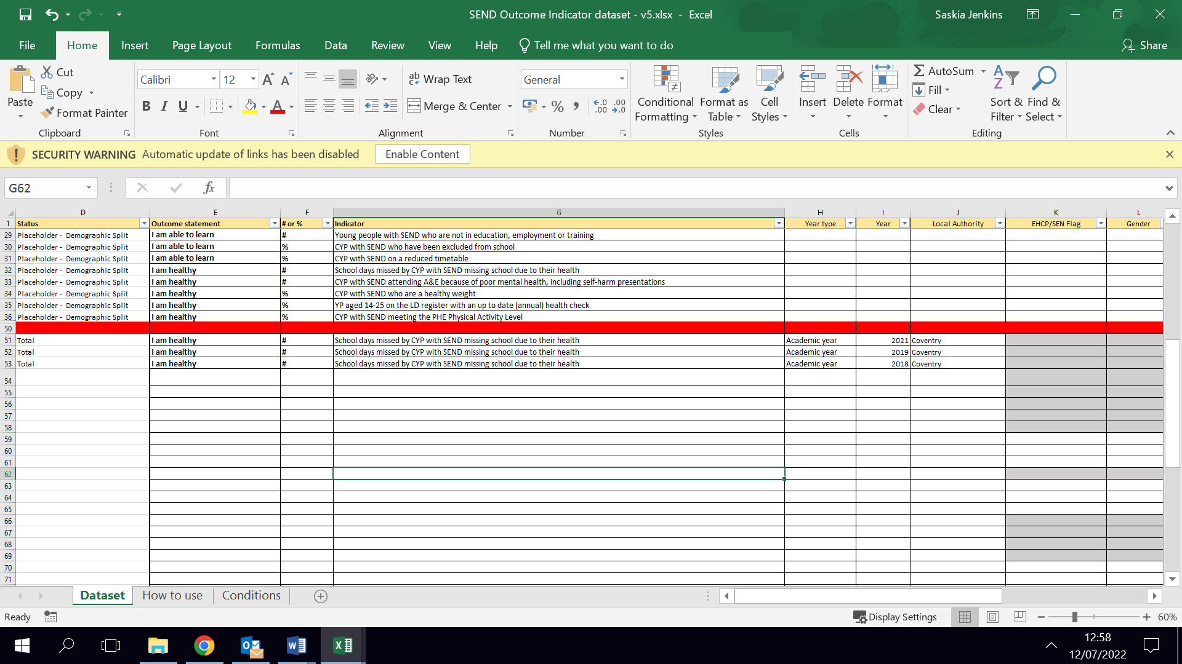

A total line should only include

* the year type (whether academic year, calendar year etc.),
* the name of the local authority area,
* the count (e.g. number of days of school missed or % of young people on the LD register who have an up-to-date annual health check) and,
* where appropriate, the total cohort (e.g. the total number of young people on the LD register).

The total rows should not include the demographic breakdowns (such as the figures broken down by gender etc out.) which have been greyed out. This can be added later (see section 2.2.4).

The total row must be copied and pasted in for **every** indicator you have data on. You cannot add lines with demographic data without first adding the total row.

**Note: Data should not be added to any cells highlighted blue or grey as these should either be left or blank or already have formulas in them that pre-populate information.**

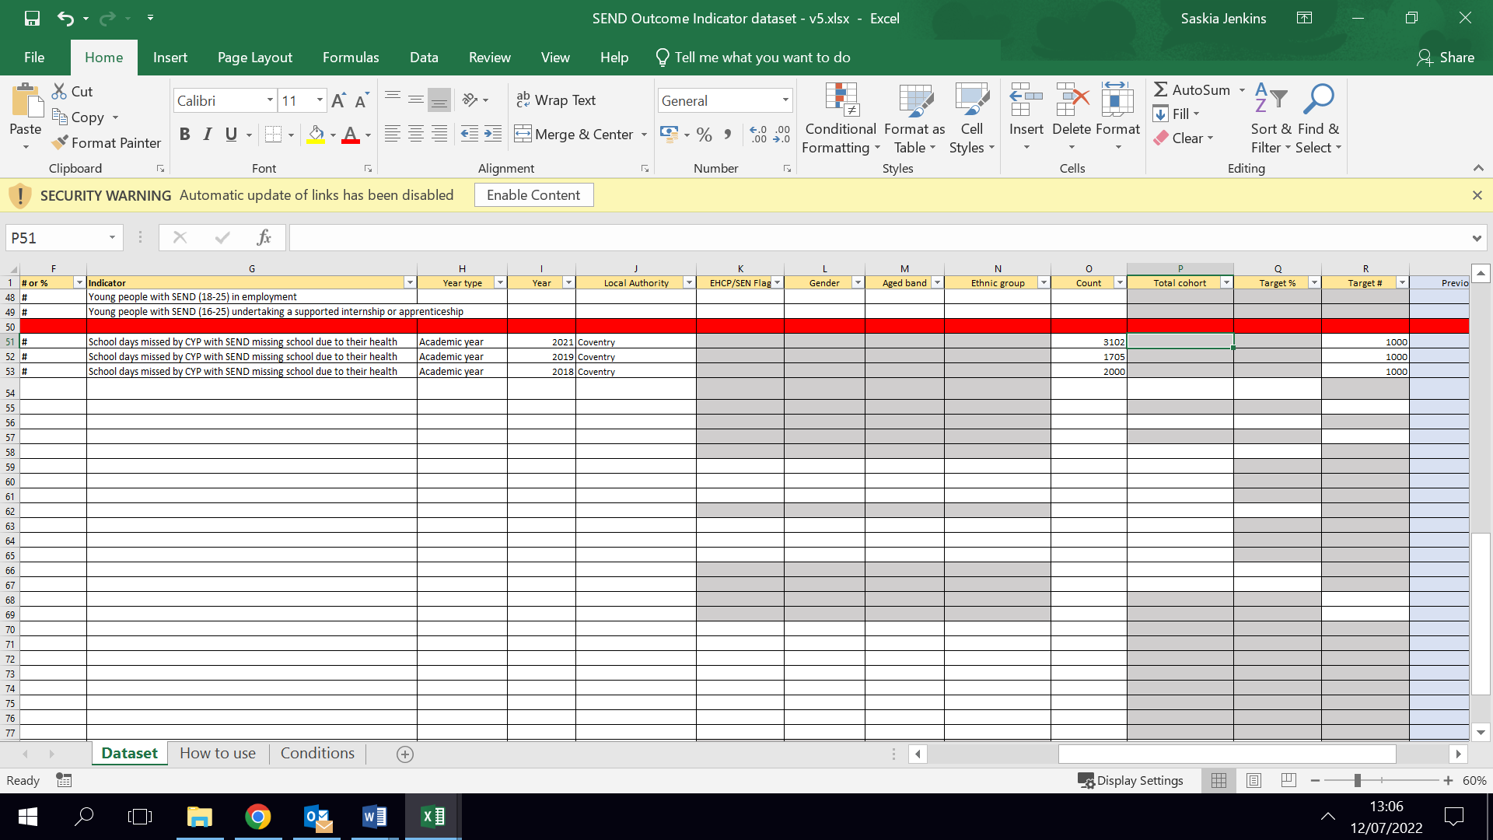You can see an example below, where all demographic data has been left blank but the total count has been added for each year:

#### Targets

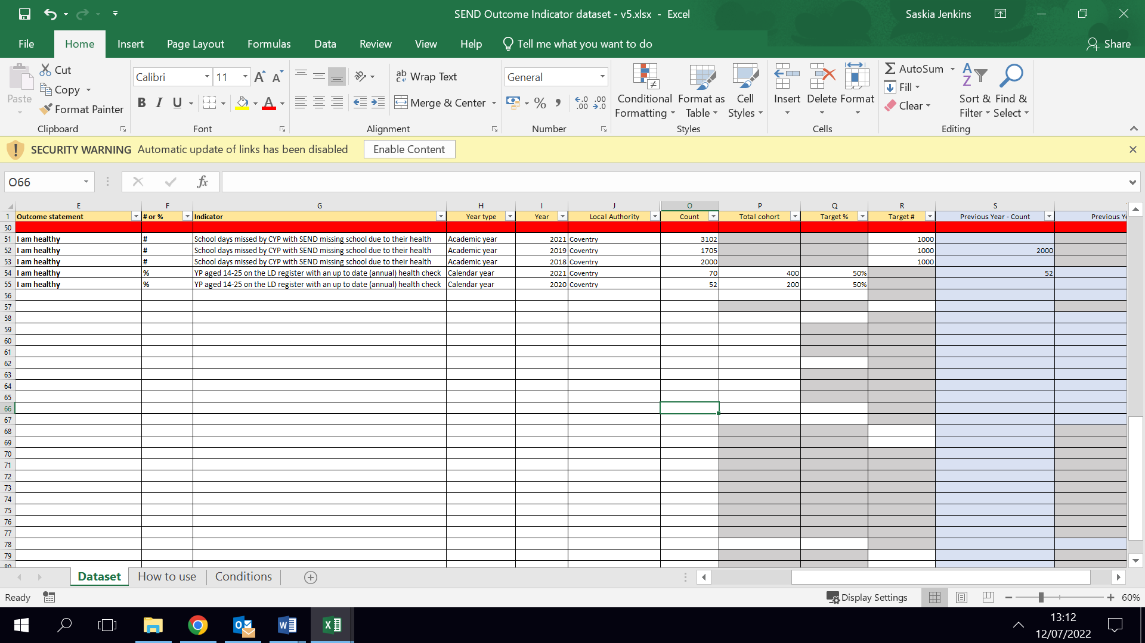There are also columns to add optional **targets** for each indicator so the dashboard can display the variance from your targets in a RAG-rated table. The target can be added either as a total number (e.g. for number of school days missed) or as a percentage (e.g. for the proportion of young people on the LD register with an up-to-date annual health check), depending on the indicator. You can see examples below:

### 2.2.4 Adding demographic breakdowns

**Note: lines of demographic data must be added in addition to the total row for each indicator**

It is possible to break the figures down by EHCP/SEN Support status, age band, gender, and ethnicity. For example, if you want to understand the take-up of annual health checks for females compared to males, and compared to young people who are gender non-conforming.

This can be added by copying the relevant ‘Placeholder – Demographic Split’ indicator row, pasting it below the red line and changing the status to ‘Demographic Split’ on that particular row.

The row will need to be copied multiple times for each demographic group. For example, if you want to add data for ‘male’, ‘female’ and ‘gender non-conforming’ children and young people, you will need to copy one row for each gender category (three of the same row in total). It may be easiest to paste these underneath the total row for that indicator. Data can then be added for each group as appropriate.

The ‘**Total Cohort**’ will need to be split for each demographic row. For example, if there are 200 young people on the LD register, that is the figure that would go in the Total row’s ‘Total cohort.’ If 80 of those 200 young people on the LD register are female, 80 is the figure that should go in the relevant Demographic Split row’s ‘Total cohort’ and so on for each gender, as shown below.

The figures (count and total cohort) in each of the demographic split rows need to collectively add up to the figures in the total row.

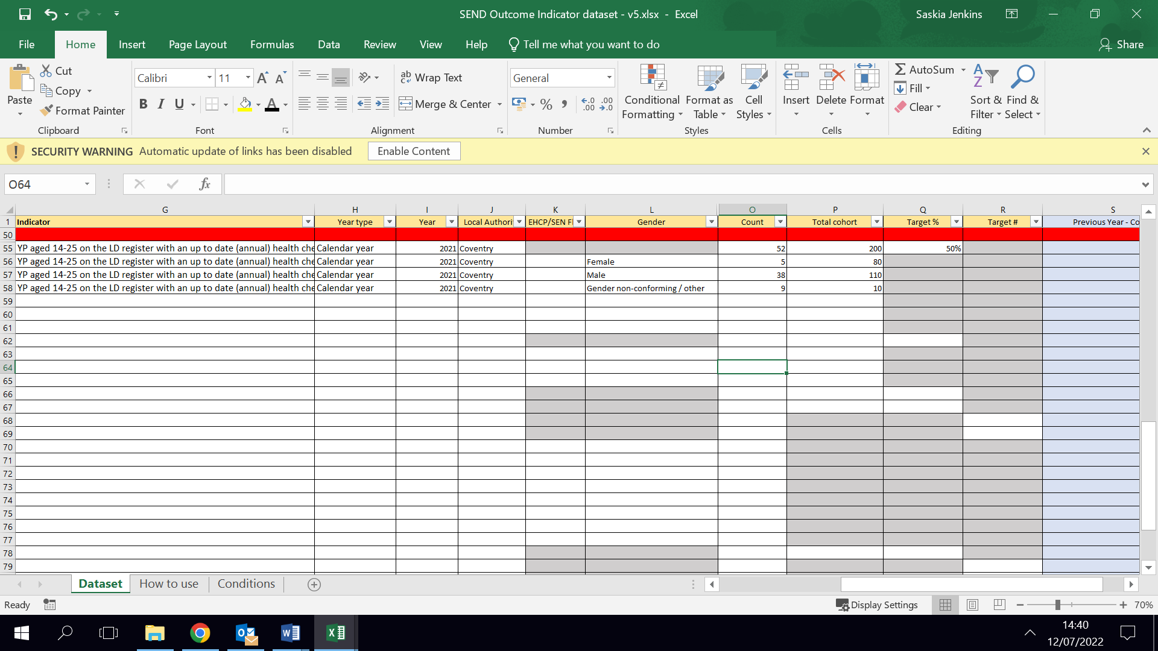

### 2.2.5 Being aware of pre-set conditions

Cells that should not be completed have been highlighted grey or blue. Limitations have been added to some cells e.g. to prevent the use of age bands 0-10 for employment related indicators. The conditions used to filter these cells can be found and updated on the conditions tab.

The dashboard includes a mixture of fixed options and bespoke options that will need to be added by you. Bespoke fields include the year, local authority and the numerical data you need to input.

It is important that the spelling of the local authority and how the year is captured is kept consistent between the data input tools and the reference table. This is further explained in section 2.2 but as an example, if the local authority was input as ‘Kingston upon Thames’ in the data input tool, but then as ‘Kingston-upon-Thames’ in the reference table, the dashboards would display an error message.

**Note:** the *# or %* column has been added to differentiate between indicators that will be shown as percentages (%) and the indicators that are total counts (#). However, **you should still add the overall figures for the % indicators**. For example, you should put in that 52 young people (the ‘Count’ figure) out of 200 young people (the ‘Total cohort’ figure) had an up to date annual health check, rather than putting in the percentage of young people with an up to date annual health check (i.e. 26%) out of the total cohort of 200. The percentage will be calculated within the dashboard.

## Indicator list and Reference tables

The indicator list contains all the agreed indicators and is used to populate the indicator list tab on both dashboards. More information about adding to the indicator list can be found in section 4.

The reference table is used to link the dataset to the questionnaire data, and it is important that the **reference table is updated**, and that the questionnaire dataset is included (even if is blank) as both are part of the model developed on Power BI.

The reference tables are pre-populated with agreed demographic splits e.g. for age and gender, based on the most common categories used for existing data collection. However, these can be updated to local bandings if preferred. Any change on the reference tables should be replicated on the other templates as well as they will not automatically read across.

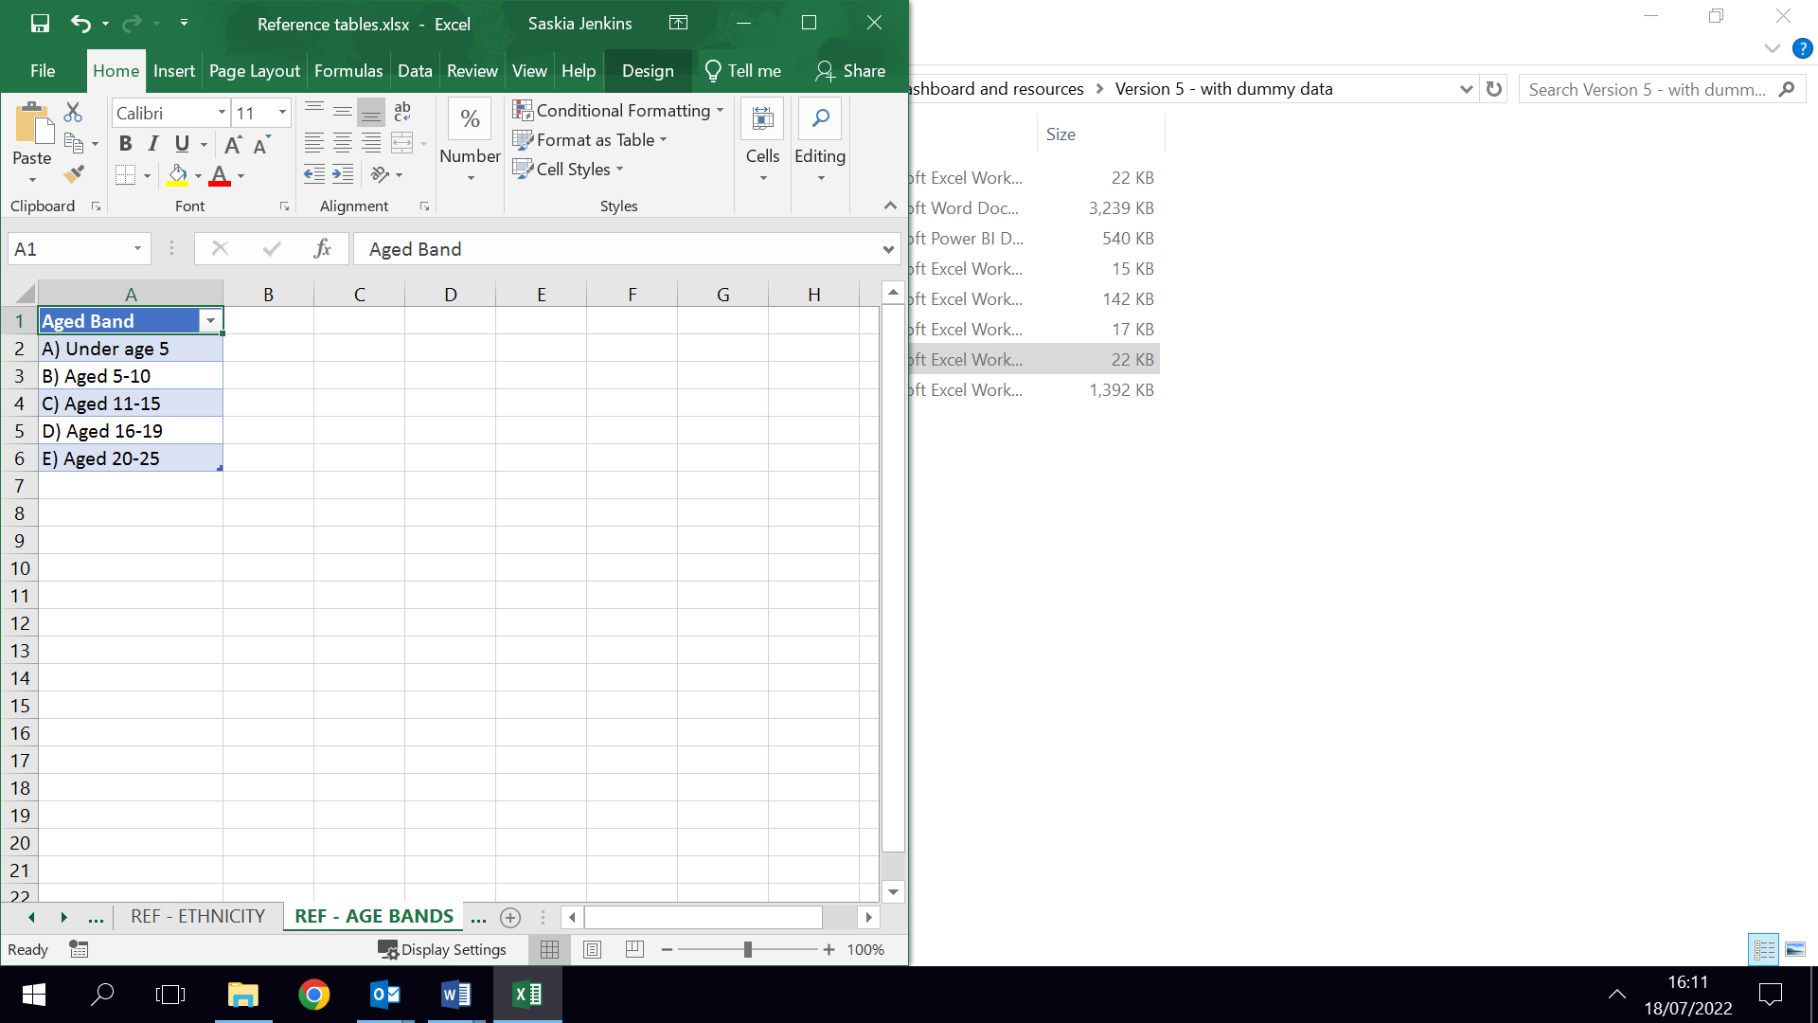

**At a minimum, the *Local Authority* table should be updated**. Remove the dummy data (where it says ‘Local Authority 1’ etc.) and replace with the name of the local authority or multiple local authorities you are inputting data for.

It is also worth noting that the reference table includes years between 2015 and 2030. If you will be inputting data going further back than 2015 or beyond 2030, these years will need to be added to the reference table.

## 2.3 Adding questionnaire data

If survey data has been collected, you will need to add this to the SEND Questionnaire dataset. The dataset template has been created with **one line per individual child or young person**. Paste the responses received from your questionnaire below the red line.

If data is being added manually, a placeholder has been created with pre-selected drop-down options. For example, for Gender the agreed options of Male, Female, Gender non-conforming/Other are available.

Pre-set response options have been added, ranging from strongly agree to strongly disagree as was agreed in consultation with children and young people, however these can also be amended if needed.

As in the Outcome indicator dataset, the placeholder should be copied below the red line for each child or young person to ensure consistency in the responses uploaded.

The relevant graphs on the dashboard will then be updated when the table is saved and uploaded to Power BI or Excel.

# **How to link to and refresh the datasets in the dashboard**

## 3.1 Uploading data to the Excel Dashboard

There are three main steps to input or refresh data in the Excel dashboard:

### 3.1.1 Copy data from the dataset template

To add your data into the Excel version of the Dashboard, copy the visible columns that are under the red line on the dataset files. This should be done by **manually** **highlighting** the cells below the red line and clicking ctrl+c (rather than selecting all cells from the column numbers on the left).

### 3.1.2 Paste data into the Excel dashboard

Depending on which dataset you are inputting, select either the ‘Indicator dataset’ or ‘Questionnaire dataset’ tab in the Excel dashboard. To paste your data, click on the first cell in column A under the red line and then select the paste icon on the home menu and select the paste option to ***keep value and source formatting***:

### 3.1.3 Refresh the dashboard

Once you have done this for both datasets**, you will need to refresh the Excel dashboard by selecting the *refresh all* button.** This can be found on the Data menu:

### 3.1.4 Filtering in Excel:

Once the data has been refreshed, you will need to select the local authorities from the filters when available. The local authority filters are linked across the dashboard. This is unlike the demographic filters which are independent of each other, as different indicators may have different types of demographic data.

The slicers are one way to filter the data. In some instances, they will have a “(blank)” option which will need to be unselected. To unselect, hold ctrl and click on the blank option on the slicer as seen in the screenshot below. Notes and warnings have been added on each tab to indicate what filters should be selected.

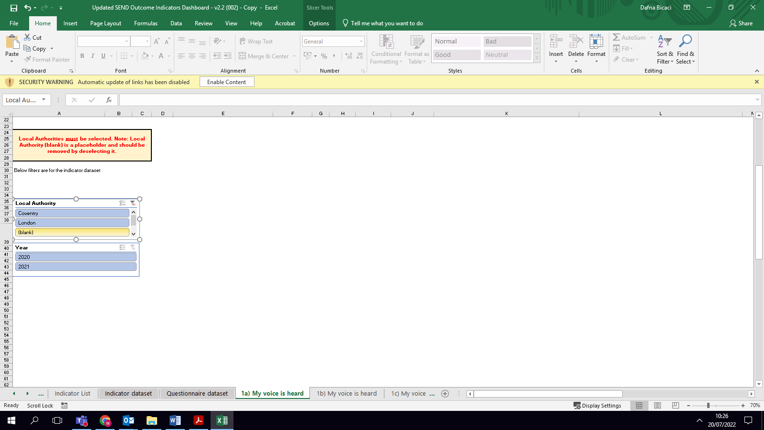

For tabs 1c-7c, you should click on the graph and pick the local authority filter from the Pivot Chart pop-up on the right. You can also choose any other filtering based on what you would like to compare, for example between age and gender.

There are multiple formulas added under *Variance from Target # and %* cells in the Excel dashboard. The formulas are copied up until row 80. If you have data that surpasses row 80, you may drag the formulas even further. Please also ensure not to delete any formulas.

## 3.2 Uploading data to the Power BI dashboard

There are two main steps to input or refresh data in the Power BI dashboard:

* Saving the files and uploading them into Power BI
* Refreshing the dashboard

### 3.2.1 Save the files into a local file area and upload them in Power BI

Firstly, save the four updated files (the indicator list, reference table, SEND Outcomes Indicator dataset, and SEND Questionnaire dataset) to a local file area.

Then, to link to them to Power BI, select ‘*File’* and then *‘Options and settings’.* This should allow you to access the ‘*Data source settings’*:

You then need to add **all four files**, including any blank files, by choosing *Change source* then browsing to find your own file location. Then click ‘OK’, and then ‘Close’.

`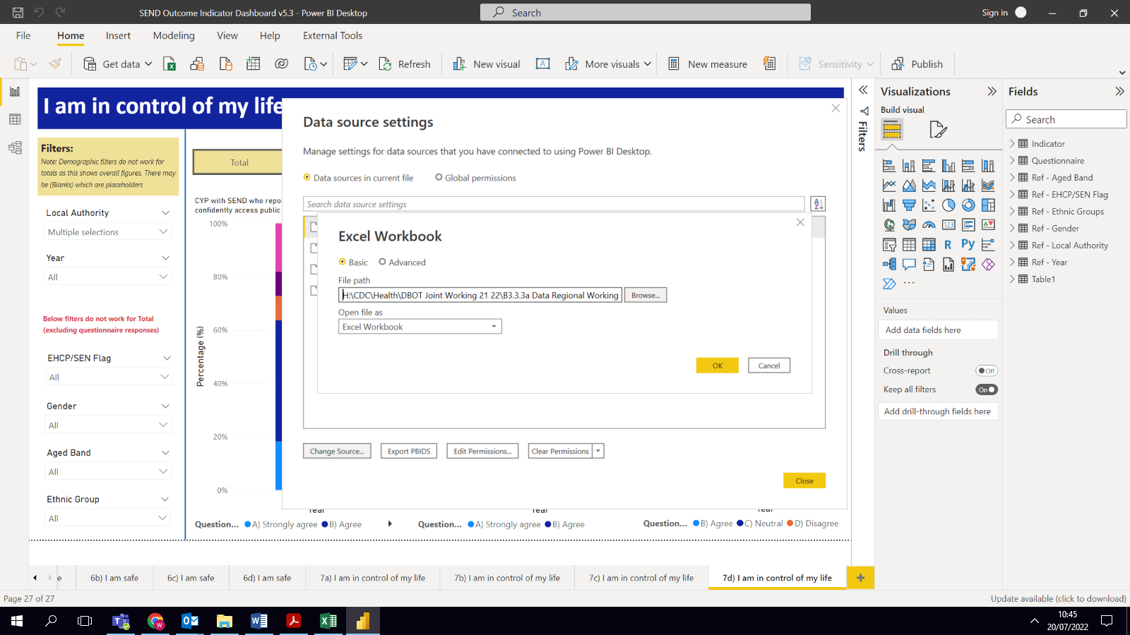

### 3.2.2 Refresh the data connections

The first time you input data, you should select the button ‘*Change source’* and then click the ‘A*pply Changes’* pop-up which will appear.

In the future, as long as the data source location remains the same, the dashboard can be updated with any new data added into the dataset template by clicking on the ‘*Refresh’* button, available on the Home tab. All tables and graphs will then be updated.

Please note, the text on the first page which shows when the dashboard was last refreshed does not update automatically and will need to manually be changed. This can be done by clicking on the text box, select ‘Text’ from the format option and updating the text accordingly.

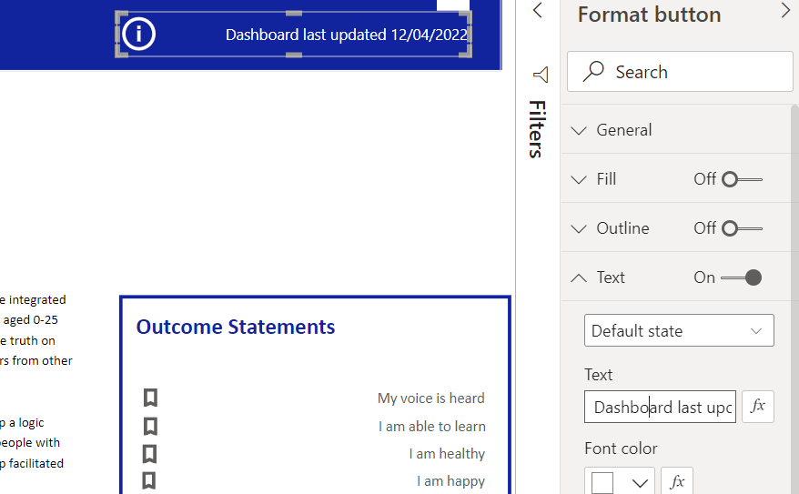

### Filtering in Power BI

Once data is uploaded and dashboard refreshed, you should be able to graphs and tables come up in the pages that have data.

In the overview pages (1-7a), total figures will be shown in table format. Pages b, c and d will include both total and demographic split data.

The filtering options (slicers) on the left can only be used for demographic split data (screenshot below). If data for a particular filter does not exist, the filters for the missing data won’t be enabled. For example, if there is data on gender but not age, you will be able to use the filter for gender. Since there is no data for age, the data is stored under the blank option. This filtering option is useful if you want to split/compare data by specific cohorts.

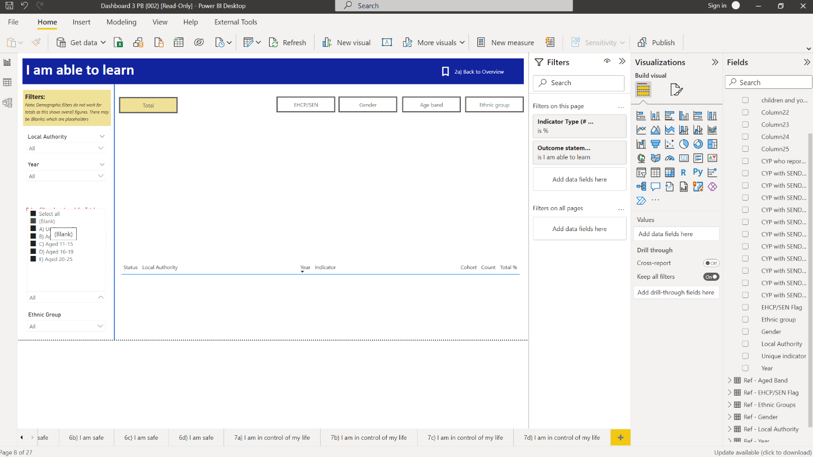`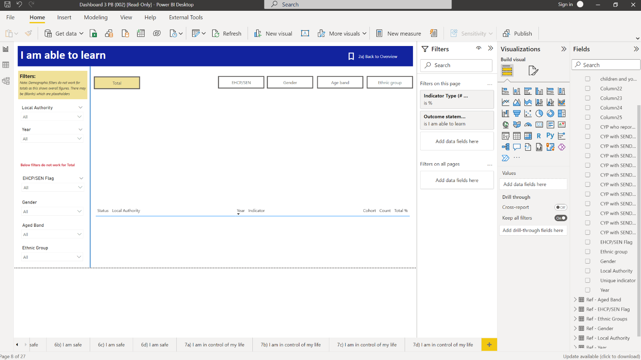`

The filters on the top (chosen by ctrl + click), display the demographic splits or Local Authority data as a total (screenshot below). The Total tab will compare Local Authorities and/or year trends. The others will compare across different demographic groups. For example, EHCP/SEN section will compare children and young people with an Education Health and Care Plan, to children and young people with SEN support for each individual indicator.

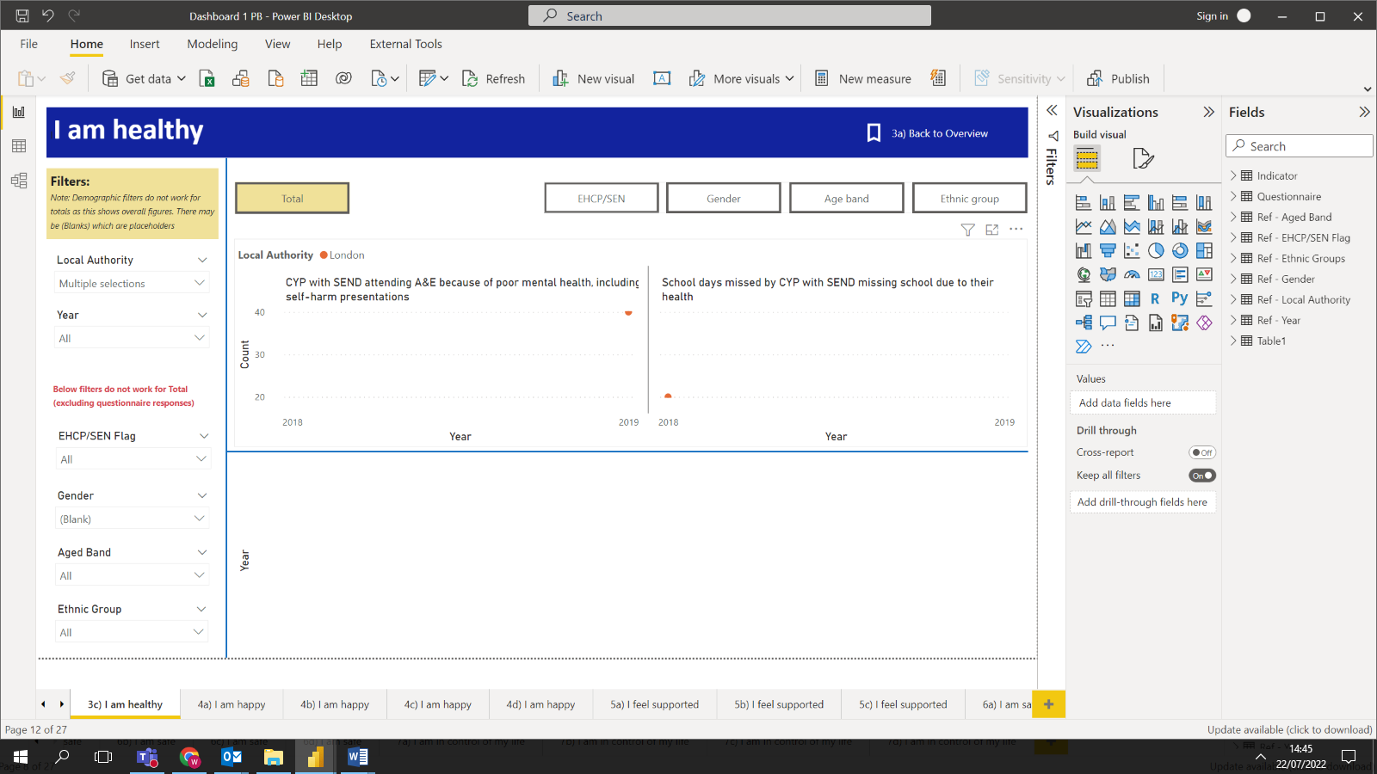

# **Personalising the dashboard - How to alter graphs and add new indicators**

*This section is about personalising the dashboard. This will be necessary if you would like to add new outcomes or indicators, add or amend graphs and change fields. The processes explained in this section are more advanced than the previous sections. Other than section 4.1 on the graphical displays, we suggest further changes are undertaken by your IT or data teams.*

## 4.1 Changing the type of graphical display in Power BI

On the Power BI dashboard, the quickest way to change a graph type is to select the graph you want to change and on the ‘*Visualizations*’ tab, click the alternative graph type you would prefer.

This is particularly useful if you want to change a bar graph showing one year of data to a trend line, for example, when you have access to data over a longer period of time.

### 4.1.1 Changing the layout of graphs and charts in Power BI

The type of graph for each indicator has been preselected so that it can best display the type of data we expect will be recorded for each indicator, whilst not overpopulating the tabs. At present, the demographic pages do not show a comparison between multiple Local Authorities on one graph, in order to reduce the likelihood of overpopulating the graph (for example, if it automatically showed data for the 5 ethnicity categories for 2 Local Authorities over 5 years, it would be very crowded).

However, this can be added if desired by

* selecting the ‘*Visualizations’* tab
* scrolling down to ‘*Small multiples’* section and clicking on the section
* expanding the *Questionnaire* tab on the *Fields* section on the right of the *visualizations* section
* checking the box of *Local Authority*

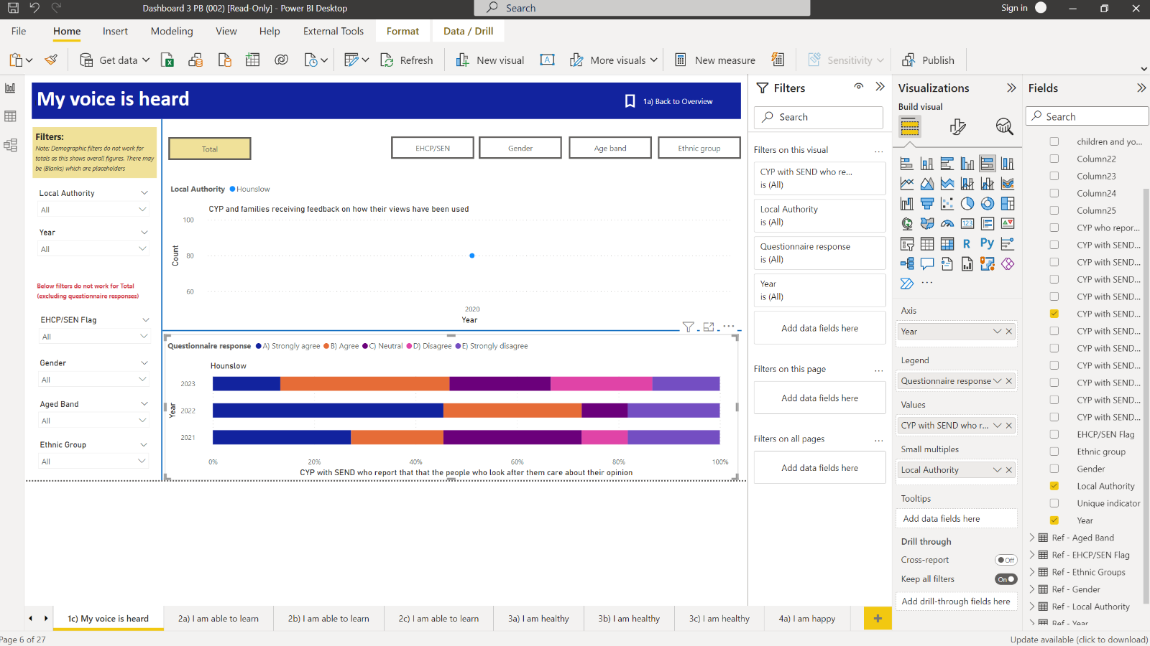

To show multiple indicators on one graph, the user can click on the graph and then use the roller brush icon (*Format your visual*) within the ‘*Visualizations’* tab. Next, select ‘*Grid layout’* or ‘*Small multiple grid’* and change the columns to capture as many indicators they would like to show on one graph:

### 4.1.2 Adding graphs for new questionnaire data in Power BI

Graphs displaying questionnaire data have been added separately.

To add a new questionnaire indicator (for example, if you want to add in data on an existing survey question), first add the field to the SEND Questionnaire dataset (Excel sheet with crude data). When the tables are refreshed, this option will now be available on the ‘*Fields’* tab.

A new graph for this additional indicator can then be added from the ‘*Visualizations’* section.

### 4.1.3 Adding graphs for new questionnaire data in Excel

If you would like to add new graphs, you first will need to create a new pivot table. To do that, click *Insert* in the ribbon and select ‘Pivot table’. Select the data from data tab. The field options can then be used on the pivot table to select the new indicator.

Click on the table and then on the ribbon select insert. Now click on the Pivot Chart. This would generate a new graph for the indicator.

For a new indicator, a new Slicer would also need to be added and connected to the main filter options on the page. To do this, click on the graph, on the ribbon click insert and then slicer.

This would add a new slicer for the graph. To link to the existing filters on the page. The *Report Connections* button can be used, and the relevant slicers added. The new slicer can then be hidden selecting the selection pane button and unchecking the slicer.

### 4.1.4 Adding a new type of demographic split and a new reference table

To add a new demographic split (for example, if you would like to break data down by Ward), this must be added to **all three template files**:

* Reference table
* SEND Outcome Indicator dataset, and
* SEND Questionnaire dataset.

Ensure that the name of the new field is consistent across the three files.

On the reference table template, you must ensure the new list is saved in a new tab and is saved as a table. **To save as a table highlight the list and click ctrl-T.**

### 4.1.5 Uploading a new reference table in Power BI

To add this new reference table to Power BI, click ‘Get data’. Find the reference table sheet. This will give several options as shown below. Select the **new table option** (rather than the new tab name.)

As long as the field names are the same across the four files, this will automatically join between the files, therefore allowing a filter from the new reference table to be added to the left-hand filter options on each page of the dashboard. The name of the table can then be changed on the fields section on Power BI by double clicking the newly added table.

Reference tables are not needed for Excel dashboard therefore the Excel dashboard will automatically get the new filters from the data you input into the dashboard, once it is refreshed. If you are unable to see the new filters, you can click on the graph you would like to view and a ‘Pivot Table Formatting’ pop-up will appear on the right. You can then choose the new filter(s) through clicking on the checkboxes.

### 4.1.6 Resolving any issues with overlapping pivot tables in Excel

The tables in the Excel dashboard have been spaced out to try to avoid issues with overlapping. However, when additional fields are added or if inputting data for more than three Local Authorities, the spacing between the tables may need to be increased. If there is not enough space between tables, an error message will occur when attempting to refresh. Additional spacing can added by inserting blank columns between the tables. Right click on the column heading and click insert.

### 4.1.7 Deleting or amending existing fields from a template

When deleting or amending an existing field, it may be necessary to reconnect the link to the indicator within the Excel and Power BI graphs.

Additionally, in the Power BI Dashboard, deleting a column may initially cause the refresh to fail because the model may no longer be able to find the relevant columns. To address this, the template would have to be removed from the model and re-added.

To do this, click the model option on the left of the Power BI i screen:

This will open the data model that is used across the dashboard and shows the relationships between different tables. To delete a table from the model, click the three dots next to the table name and then select Delete from model. The updated template with the alterations on existing fields can now be re-uploaded.

# **Troubleshooting**

The processes outlined in the How to Guide have been tested extensively. If you receive an error message, please make sure you read the guide in full and try to reupload material. You can also consult the How to video.

Below are some common errors:

1. It is important that the spelling of the local authority and how the year is captured is kept consistent between the data input tools and the reference table *(for example, being mindful of abbreviations and ensuring consistency if using ‘&’ or ‘and’)*
2. Make sure to upload all FOUR templates in Power BI even if you don’t have data for all (*for example, you must upload the SEND Questionnaire template, even if it is blank at the moment)*
3. Ensure you have uploaded the correct templates in Power BI
   1. When you *Change Source* of a particular file, it needs to match what the existing file already says. For example, in the screenshot below, the first file is called ‘indicator list’, therefore you should replace this file with the new indicator list that you have downloaded.

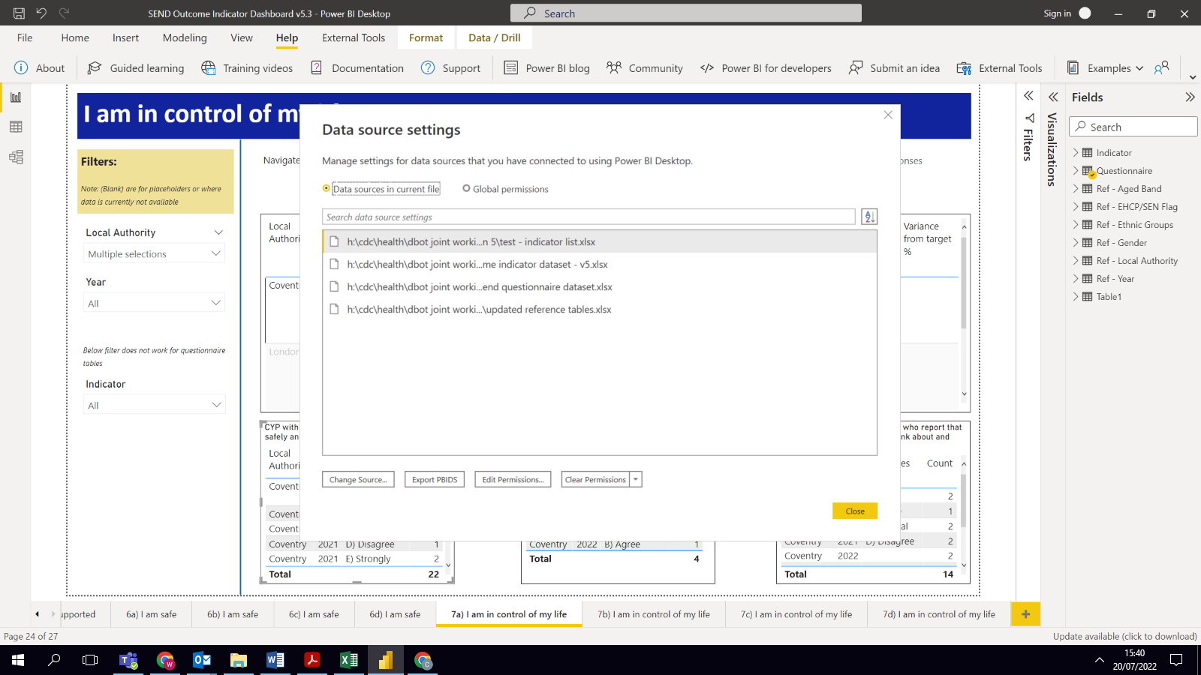

1. When you copy and paste data rows from the Indicator Dataset to the Excel dashboard, make sure the columns match the inputted values. One way to mitigate the risk of columns not matching is to highlight the cells manually rather than highlighting through the row numbers on the left
2. Make sure you paste data into the Excel dashboard using the correct paste option: ‘*keep source and formatting*’, rather than pasting as normal (*See section 3.1.2 for more information*)
3. Make sure to refresh the dashboard (in both Power BI and Excel) whenever you have updated the data (*See sections 3.1.3 and 3.2.2 for more information*)
4. For every indicator you have data on, you must add a ‘Total’ row. You cannot add demographic split rows without this
5. The ‘Total Cohort’ will need to be split for each demographic row
6. Make sure there are no duplicates (for example multiple Total rows for the same indicator, local area and year) in the Indicator Dataset
7. Make sure you have updated the reference tables. (*For example, making sure the reference tables have been updated to include the name of your local area(s))*