**What is an annual health check?**

* Annual health checks are for people with a learning disability
* An annual health check is done by your doctor once a year
* It is there to help you stay health
* You can get an annual health check if you are ages 14 or over

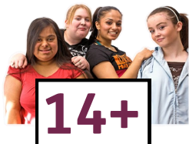

**Why is it good to have an annual health check?**

* You can talk to your doctor about anything you are worried about
* You can get to know your doctor better
* You can learn ways to be healthier
* 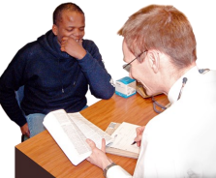If there is anything wrong, the doctor can help before it gets worse

**What happens at your annual health check?**

Your doctor or nurse from your surgery may:

* Check things about your body like your heart or your blood pressure
* 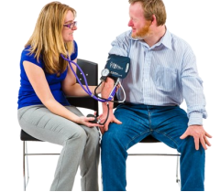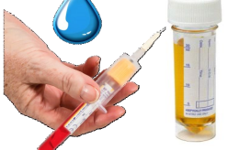Ask about any medicines you are taking
* Ask about the food you eat
* Check your blood and wee
* Ask how you are feeling

**Top tips for your annual health check**

* You can bring someone with you if you like
* Ask the doctor any questions you have or anything you are unsure of
* Tell the Doctor how you really feel
* Take your time
* You can say no at any point in the health check if there is anything you don’t want to do
* Remember your doctor is there to help you so don’t feel worried.